**Aishwary Sharma**

**2022CH11437**

**Group-1**

**Tut-7**

Q1.

**A-**

**(1)** Summation Method :

// Header files and namespaces

#include<bits/stdc++.h>

using namespace std;

void lstf(vector<int> v){

for(int i= 0;i< v.size();i++){

cout << v[i]<< " ";

}

}

//Summation method for 1 independent variable (x,y)

vector<double> summation1reg(vector<double>x , vector<double>y){

//y_pred = a1*x + a0

//a1 = (N*SIGMA(xi*yi)-SIGMA(xi)*SIGMA(yi))/N*SIGMA(xi^2)-(SIGMA(xi))^2

//a0 = SIGMA(yi)/N - (SIGMA(xi)/N)*a1

int N = x.size();

double sum_xi = 0;

for(int i= 0; i<N;i++){

sum_xi += x[i];

}

// cout <<"sum_xi = " <<sum_xi ;

double sum_yi = 0;

for(int i= 0; i<N;i++){

sum_yi += y[i];

}

//cout <<"sum_yi = " <<sum_yi ;

double sum_xi_sq = 0;

for(int i= 0; i<N;i++){

sum_xi_sq += (x[i])*(x[i]);

}

//cout <<"sum_xi_sq = " <<sum_xi_sq;

double sum_xi_yi = 0;

for(int i= 0; i<N;i++){

sum_xi_yi += (x[i])*(y[i]);

}

//cout <<"sum_xi_yi = " <<sum_xi_yi ;

double a1 = ((N*sum_xi_yi)-(sum_xi*sum_yi))/((N*sum_xi_sq)-(sum_xi*sum_xi));

double a0 = ((sum_yi/N)-(sum_xi/N)*a1);

cout << "y_pred = "<< a1 << "x + "<< a0 ;

cout << "y_pred values : " << endl ;

vector<double> y_pred ;

for(auto val : x ){

double value = a1*val + a0 ;

y_pred.push_back(value);

cout<< value << endl;

}

return y_pred;

}

double y_avg(vector<double>y){

double sum = 0;

for(int i = 0; i<y.size();i++){

sum += y[i];

}

return sum/y.size() ;

}

double S_r(vector<double>y, vector<double>y_pred){

double Sr = 0 ;

for(int i = 0; i<y.size();i++){

Sr += pow((y[i]-y_pred[i]),2) ;

}

return Sr ;

}

double S_t(vector<double>y, double y_avg){

double St = 0 ;

for(int i = 0; i<y.size();i++){

St += pow((y[i]-y_avg),2) ;

}

return St ;

}

int main(){

vector<double> x = {1,2,3,4,5,6,7};

vector<double> y = {0.5,2.5,2.0,4.0,3.5,6.0,5.5};

vector<double>y_pred = summation1reg(x,y);

double yavg = y_avg(y);

double St = S_t(y,yavg);

double Sr = S_r(y,y_pred);

double r2 = (St-Sr)/St ;

// cout << St << " " << Sr << " " << r2;

cout << "Correlation coefficient is: "<< sqrt(r2);

}

Output-

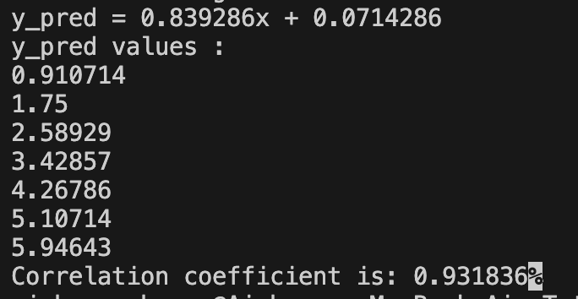

**(2)** Matrix Method : (Implementation for in general multilinear Regression model with any number of parameters)

#include<bits/stdc++.h>

using namespace std;

// printing matrix

void lstf(vector<vector<double>>arr){

for(int i = 0 ; i < arr.size() ; i++){

for(int j = 0; j< arr[0].size() ; j++){

cout << arr[i][j] << " ";

}

cout << endl ;

}

}

void pivot(vector < vector<double> >& v , vector < vector<double> >& I, int k ){

// k --> arr[k][k]

int n = v.size() ;

double big = v[k][k] ;

int p = k ;

for(int i = k+1 ; i< n; i++){

if(v[i][k] > big){

big = v[i][k];

p = i ;

}

}

if(p != k ){

swap(v[p],v[k]);

swap(I[p],I[k]);

}

}

vector<vector<double>> inverseMatrix( vector<vector<double>>& mat) {

int n = mat.size();

int m = mat[0].size();

if (n != m){

cout << "Dimension error" << endl ;

exit(1);

}

vector<vector<double>>Iden(n,vector<double>(n,0));

for(int i = 0 ; i< n; i++){

Iden[i][i] = 1 ;

}

for(int k = 0; k<n ; k++){

pivot(mat,Iden,k);

double div = mat[k][k];

if(abs(div) < 1e-05 ){

cout << "Not invertible";

exit(1);

}

for(int j = k ; j< n ; j++){

mat[k][j]= mat[k][j]/div;

}

for(int j = 0 ; j< n ; j++){

Iden[k][j]= Iden[k][j]/div;

}

for(int l = 0; l< n; l++){

if(l == k){

continue;

}

else{

double factor = mat[l][k];

for(int j = k ; j<n; j++ ){

mat[l][j] = mat[l][j] -factor*mat[k][j];

if(abs(mat[l][j])<1e-05){

mat[l][j] = 0;

}

}

for(int j = 0 ; j<n; j++ ){

Iden[l][j] = Iden[l][j] -factor*Iden[k][j];

if(abs(Iden[l][j])<1e-05){

Iden[l][j] = 0;

}

}

}

}

}

cout << "the inverse matrix: " << endl ;

lstf(Iden);

return Iden ;

}

// Matrix Multipication

vector<vector<double>> matrixMultiply( vector<vector<double>>& A, vector<vector<double>>& B) {

int m = A.size(); // Number of rows in A

int n = A[0].size(); // Number of columns in A

int p = B[0].size(); // Number of columns in B

// Initialize the result matrix C with dimensions mxp

vector<vector<double>> C(m, vector<double>(p, 0));

// Perform matrix multiplication

for (int i = 0; i < m; ++i) {

for (int j = 0; j < p; ++j) {

for (int k = 0; k < n; ++k) {

C[i][j] += A[i][k] * B[k][j];

}

}

}

return C;

}

// Transpose of matrix

vector<vector<double>> transpose( vector<vector<double>>& matrix) {

int rows = matrix.size();

int cols = matrix[0].size();

// Initialize the transpose matrix with dimensions cols x rows

vector<vector<double>> transpose(cols, vector<double>(rows, 0));

// Fill in the transpose matrix

for (int i = 0; i < rows; ++i) {

for (int j = 0; j < cols; ++j) {

transpose[j][i] = matrix[i][j];

}

}

return transpose;

}

int main(){

ifstream in("Input1.txt");

//vector < vector<double> > test = {{2,-1,0,1},{0,1,2,3},{0,1,1,2},{2,5,1,4}};

//inverseMatrix(test);

int m , n;

//cout << "No. of rows in data- ";

in >> m ;

//cout << "No. of independent variables- ";

in >> n ;

//cout << " y1 - ym: ";

// cout << m << " " << n ;

vector<vector<double>> Y(m,vector<double>(1,0)) ;

for(int i =0; i<m; i++){

in >> Y[i][0];

}

vector<vector<double>> X(m,vector<double>(n+1,1));

for(int i = 1; i<n+1 ;i++){

//cout << "Feature "<< i<<" from 1-m";

for(int j = 0; j<m ; j++){

in >> X[j][i];

}

}

//vector<vector<double>> X = {{1,1,1,1,1,1,1},{1,2,3,4,5,6,7}};

//vector<vector<double>> Y = {{0.5},{2.5},{2.0},{4.0},{3.5},{6.0},{5.5}};

cout << " X: " << endl ;

lstf(X);

cout << "Y: " << endl ;

lstf(Y);

vector<vector<double>>transpose_X = transpose(X);

cout << "transpose(X) : "<< endl ;

lstf(transpose_X);

vector<vector<double>>XTcrsX = matrixMultiply(transpose_X,X);

cout << "XTcross X : "<< endl ;

lstf(XTcrsX);

vector<vector<double>> XTcrsX_inv = inverseMatrix(XTcrsX);

cout << " Xt x X inverse" << endl ;

lstf(XTcrsX_inv);

vector<vector<double>>XTcrsY = matrixMultiply(transpose_X,Y) ;

vector<vector<double>> phiVector = matrixMultiply(XTcrsX_inv,XTcrsY);

cout << "The parameters (a0-an): " << endl ;

lstf(phiVector);

}

Output-

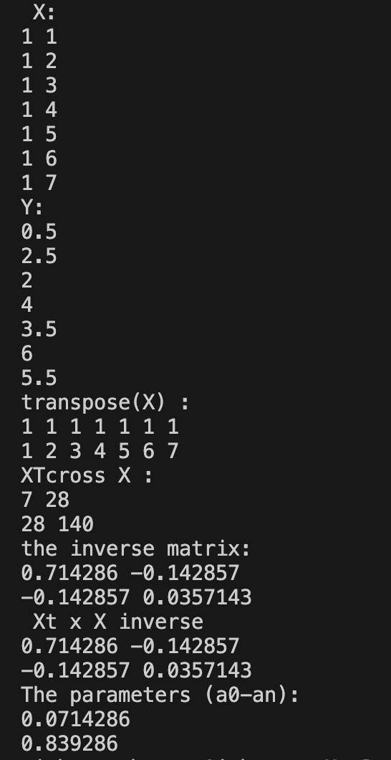

B- (Interchanging x and y)

The values of parameters (a0 and a1) have changed. The regression line remains the same just the orientation is changed.

Q2.

(1)- Summation method for 2 independent variables

// summation menthod for 2 independent variables

#include<bits/stdc++.h>

using namespace std;

// printing matrix

void lstf(vector<vector<double>>arr){

for(int i = 0 ; i < arr.size() ; i++){

for(int j = 0; j< arr[0].size() ; j++){

cout << arr[i][j] << " ";

}

cout << endl ;

}

}

void pivot(vector <vector<double> >& v , int k ){

// k --> arr[k][k]

int n = v.size() ;

double big = v[k][k] ;

int p = k ;

for(int i = k+1 ; i< n; i++){

if(v[i][k] > big){

big = v[i][k];

p = i ;

}

}

if(p != k ){

swap(v[p],v[k]);

}

}

vector<double> GaussElimination(vector<vector<double>>AugMatrix){

int n = AugMatrix.size();

for (int k = 0 ; k < n ; k++){

pivot(AugMatrix,k);

for (int i = k+1 ; i < n; i++){

double factor = AugMatrix[i][k]/AugMatrix[k][k];

for(int j = 0; j<n+1; j++){

AugMatrix[i][j] = AugMatrix[i][j]- factor* AugMatrix[k][j];

if (abs(AugMatrix[i][j]) < 1e-05){

AugMatrix[i][j] = 0 ;

}

}

}

}

vector<double> sol(n);

double xn = AugMatrix[n-1][n]/ AugMatrix[n-1][n-1];

sol[n-1] = xn ;

for(int i = n-2; i >= 0; i--){

double bi = AugMatrix[i][n];

double Xi = 0;

for(int j = i+1 ; j< n ; j++){

Xi = Xi + AugMatrix[i][j]*sol[j];

}

double xi = (bi-Xi)/AugMatrix[i][i];

sol[i]= xi;

}

return sol ;

}

void fns(vector<double>x, vector<double>u, vector<double>y){

int n = x.size();

cout << "n = " << n << endl;

double sum_xi = 0;

for(int i= 0; i<n ; i++){

sum_xi += x[i];

cout << sum_xi << " ";

}

cout << endl ;

double sum_ui = 0;

for(int i= 0; i<n ; i++){

sum_ui += u[i];

}

double sum_xi_xi = 0;

for(int i= 0; i<n ; i++){

sum_xi_xi += x[i]*x[i];

}

double sum_ui_ui = 0;

for(int i= 0; i<n ; i++){

sum_ui_ui += u[i]*u[i];

}

double sum_ui_xi = 0;

for(int i= 0; i<n ; i++){

sum_ui_xi += u[i]*x[i];

}

double sum_yi_xi = 0;

for(int i= 0; i<n ; i++){

sum_yi_xi += y[i]*x[i];

}

double sum_yi_ui = 0;

for(int i= 0; i<n ; i++){

sum_yi_ui += y[i]*u[i];

}

double sum_yi = 0;

for(int i= 0; i<n ; i++){

sum_yi += y[i];

}

//Augumented Matrix

vector<vector<double>> A = {{ double(n), sum_xi, sum_ui, sum_yi},

{sum_xi, sum_xi_xi,sum_ui_xi,sum_yi_xi},

{sum_ui,sum_ui_xi, sum_ui_ui,sum_yi_ui}};

lstf(A);

vector<double> coefficients = GaussElimination(A) ;

cout << "The coefficients are (ao- a3): " << endl ;

for (auto x: coefficients){

cout << x << endl ;

}

}

int main(){

ifstream in("Input-2.txt");

int m ;

//cout << "No. of rows in data- ";

in >> m ;

cout << m << endl ;

vector<double> y(m) ;

for(int i =0; i<m; i++){

in >> y[i];

// cout << y[i] << " ";

}

// cout << endl ;

vector<double> x(m);

for(int i = 0; i<m ;i++){

in >> x[i];

// cout << x[i] << " ";

}

// cout << endl;

vector<double> u(m);

for(int i = 0; i<m ;i++){

in >> u[i];

// cout << u[i] << " ";

}

fns(x,u,y) ;

}

**Output-**

For(y1)

For(y2)

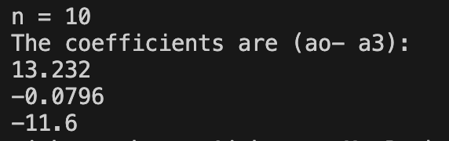

Q2- Using Matrix Method (code same as A-2)

For (y1):

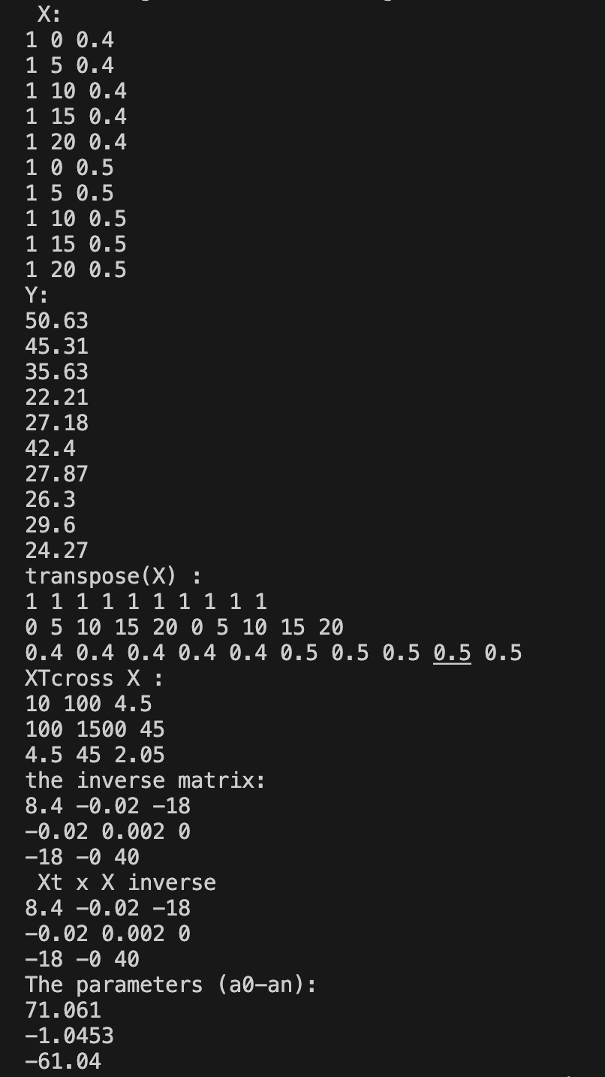

For y2:

